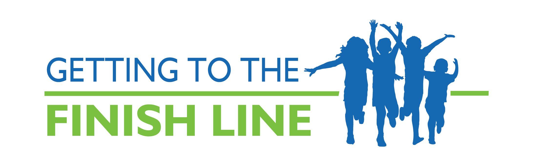
This editorial from California takes Gov. Schwarzenegger to task for his wavering support for health reform and his recent statements about cutting the Healthy Families program. This piece uses strong arguments about cost-effectiveness, especially when it comes to federal funding, and the potential side effects, including job loss, that could occur in California should Gov. Schwarzenegger take drastic action. Finally, the editorial calls on the governor to show renewed leadership and present a budget that shows that California values the health and well-being of its children and families.

San Jose Mercury News (CA) (Editorial) – Editorial: California should limit health care cuts – 5.13.2010

Two weeks ago, Gov. Arnold Schwarzenegger pledged California's full support for national health care reform.

The governor has to put his words into action today when he releases his revised state budget plan. Californians will be able to tell a lot about his commitment to health care by how he closes the $18 billion budget gap.

Schwarzenegger has been less than supportive of state health reforms for the past two years, since national reform has loomed. But he showed strong leadership in 2007, when he spearheaded a credible effort to overhaul the state's health care system and bring universal coverage to California. This is the time to renew his commitment.

Major cuts in spending are inevitable. But Schwarzenegger still can be a leader in implementing national reform by maximizing California's ability to collect federal health care dollars and by protecting the state's core health care programs as best he can.

Rumors have been floating for the past week that Schwarzenegger would eliminate California's Healthy Families program, which provides health insurance for nearly 900,000 low-income children. We don't believe it. It would be crazy. The national health care reforms were designed specifically so that if states tried to curb or cap their children's health care insurance programs, they would forgo not just federal contributions for these programs but all of their Medicaid dollars. That would cost California $26 billion, about a third more than the current deficit.

Schwarzenegger might ask the federal government to reopen negotiations on the issue, but Congress isn't going to budge. House Speaker Nancy Pelosi is adamant. If Congress caves in to California, every other state would want the same deal. The governor would be better off asking for additional federal funds to more directly help with the deficit.

Deep spending cuts on health care already have put the health of thousands of Californians at risk. The governor and the Legislature must work together to balance the budget without destroying the foundation needed to implement federal reforms. That means minimizing Medi-Cal recipients' benefit cuts and avoiding sharp reductions to health care provider rates.

Slashing health care programs has an often-overlooked side effect on California. According to a recent UC Berkeley study, one out of every 10 Californians works in the health care or social assistance professions. If California follows through on the $6.4 billion cuts in the governor's January budget proposal, it would eliminate an estimated 40,000 jobs throughout the state.

Schwarzenegger told reporters recently, "The bottom line is I don't see it as a Republican issue or a Democrat issue. I think that everyone needs health care insurance. Everyone needs to be covered. Everyone ought to have access."

The governor can follow through by presenting a budget that does the least possible damage to the state's health care programs and positions California to become a leader in the national health care reform movement.

