Zotero Research Database Now Available for CCF State Partners

What is it? Zotero is a free online database that allows you to collect, organize, cite and share research. The Georgetown CCF library on Zotero is a compilation of resources relevant to our work that is now available for our state partners.

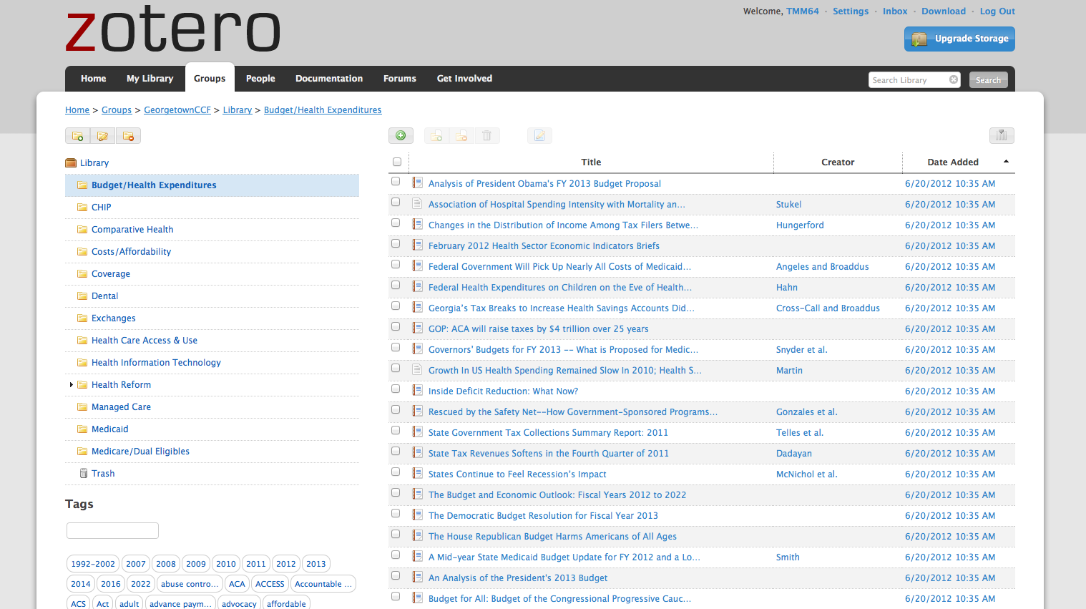

Why should I use the Georgetown CCF library on Zotero?
- Quickly search resources that are relevant to your work. The database is updated monthly and it presently contains resources dating back to January 2011.
- Access Zotero on the web or as an application on your desktop.
- Easily create citations, bibliographies and quick reports for an overview of selected resources.

How do I gain access to the Georgetown CCF library on Zotero?
1) Sign up for your own Zotero account at www.zotero.org
2) Search for the GeorgetownCCF library by either entering:
a) The group URL in your address bar: www.zotero.org/groups/georgetownccf or
b) “GeorgetownCCF” in the group search function: https://www.zotero.org/search/type/group
3) Click “Join,” - a notification will be sent to the group administrator who will approve your request as soon as possible
4) Get started with this short video: http://www.zotero.org/support/quick_start_guide
5) If you have any issues getting access, contact Tara Mancini at tmm64@georgetown.edu

Disclaimer: This library is provided by Georgetown CCF to state partners as a convenient way to search resources related to our work. The resources come from a wide-range of organizations with diverse viewpoints and variation in methodological rigor and therefore, inclusion in the group library does not constitute endorsement by the Georgetown Center for Children and Families.

