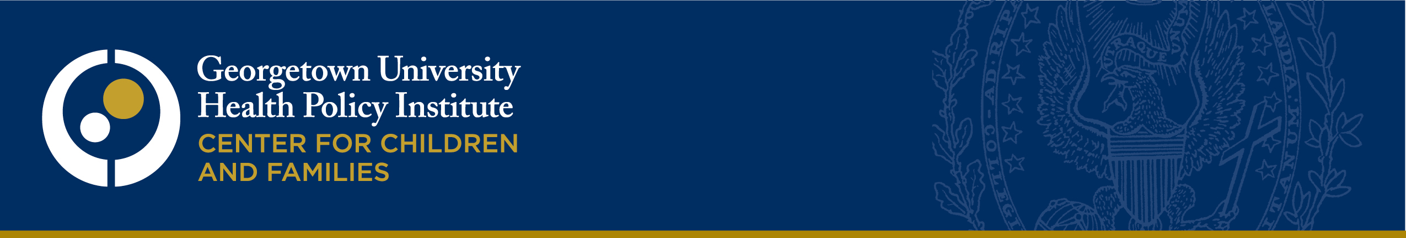
August 26, 2013
Internal Revenue Service
Re: CC:PA:LPD:PR (Notice 2013-41)
Room 5203
P.O. Box 7604
Ben Franklin Station
Washington, DC 20044
Re: Notice 2013-41
To Whom It May Concern:
The Georgetown University Center for Children and Families appreciates the opportunity to provide comment on the IRS notice on Eligibility for Minimum Essential Coverage for Purposes of the Premium Tax Credit (Notice 2013-41). The Center for Children and Families is an independent, nonpartisan policy and research center whose mission is to expand and improve health coverage for America's children and families.
We strongly support the Notice’s determination that children affected by CHIP waiting periods will be considered ineligible for minimum essential coverage and eligible to receive premium tax credits for the purchase of qualified health plans. CHIP waiting periods can leave families without access to affordable coverage for their children. Since an overriding purpose of the Affordable Care Act is to provide access to affordable coverage for those without it, children who go without coverage due to CHIP waiting periods appropriately have access to the ACA’s coverage subsidies, including premium tax credits and cost-sharing reductions.
The same principle should apply to children who are without coverage due to a CHIP lockout period and we urge IRS to revise the guidance on CHIP lockouts. Such children may not access CHIP coverage, therefore they should not be considered eligible for minimum essential coverage for any month in which they are not actually eligible for CHIP coverage. The statute specifies at 26 USC 36B(c)(2)(B)(i) that the “term ‘coverage month’ shall not include any month with respect to an individual if for such month the individual is eligible for minimum essential coverage other than” individual market coverage. During a lockout period, children are not eligible for CHIP coverage and thus cannot be considered eligible for minimum essential coverage under section 5000A(f)(1)(A)(iii). While 26 CFR § 1.36B-2(c)(2)(ii) requires compliance with administrative requirements for coverage, the requirement to pay premiums falls on parents, not children. Because a child is not required meet administrative requirements, the child’s eligibility should not be affected by this regulatory provision.
Barring children from eligibility for premium tax credits during CHIP lockout periods puts children’s health at risk. Children in families who can access neither CHIP coverage nor premium tax credits are likely to go without any health coverage. A gap in coverage of up to 90 days can result in delayed care with subsequent serious health and developmental consequences.
Forcing locked-out children to go without coverage also puts families’ financial stability at risk at a particularly vulnerable time. Families struggling to pay CHIP premiums should not be exposed to the financial risks that an uncovered child can present—a single hospital admission can put many families at risk of bankruptcy. While these families may also struggle to pay qualified health plan premiums even after a tax credit, the protection from catastrophic costs offered by QHPs is vastly preferable to leaving families without any coverage option for their children.
We see no justifiable policy reason to treat children who are not covered by CHIP due to a waiting period differently from children who are not covered due to a lockout period. Under the ACA, nearly all parents are expected to assure that their children have health coverage and both waiting periods and lockout periods are problematic policies. While other agencies set CHIP rules, the IRS can best fulfill the goals of the ACA by revising its guidance to make it possible for parents to maintain coverage for children consistently, even if parents have failed to pay CHIP premiums.
Thank you for your consideration. Any questions about these comments may be directed to Joe Touschner at jdt38@georgetown.edu.
Sincerely,
Georgetown University Center for Children and Families

