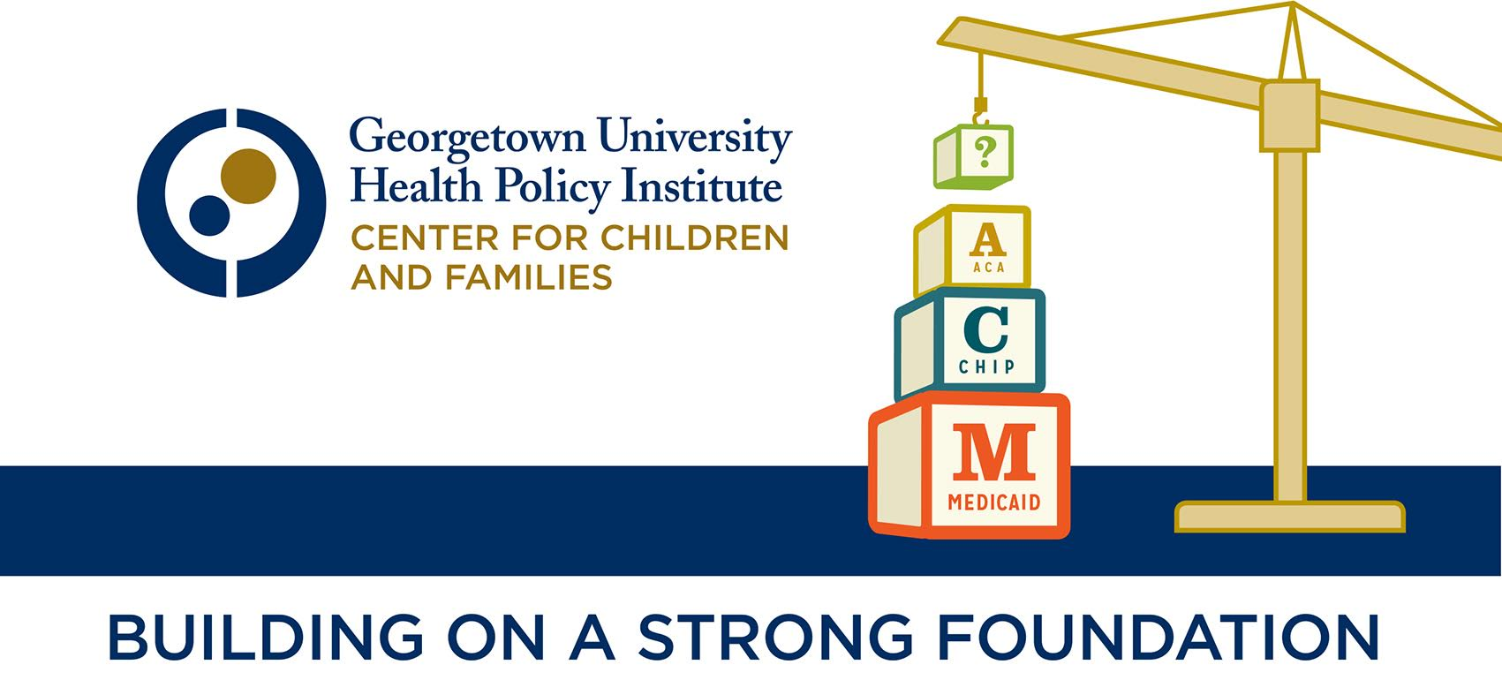

Evaluation Form
If filling out after the conference, please email to sophia.duong@georgetown.edu

1. Please rate the following aspects of the conference:

 | 1 | 2 | 3 | 4
Registration Process | Poor | Fair | Good | Excellent
Venue | Poor | Fair | Good | Excellent
Format and Scheduling | Poor | Fair | Good | Excellent
Meals | Poor | Fair | Good | Excellent
Overall Experience | Poor | Fair | Good | Excellent

2. Did the conference meet your expectations? Explain why or why not.
_____________________________________________________________________________________________________________________________________________________________________________________________________________________________________________________________________________________________________________________________________________________________________________________________________________________________________________________________________________________________________________________________________________
_________________________________________________________________________________________________________

3. What was the most helpful session(s) to your work and why?
_____________________________________________________________________________________________________________________________________________________________________________________________________________________________________________________________________________________________________________________________________________________________________________________________________________________________________________________________________________________________________________________________________________
_________________________________________________________________________________________________________
4. What was the least helpful session(s) to your work and why?
_____________________________________________________________________________________________________________________________________________________________________________________________________________________________________________________________________________________________________________________________________________________________________________________________________________________________________________________________________________________________________________________________________________
_________________________________________________________________________________________________________
5. If you could change one thing about the conference, what would it be and why?
_____________________________________________________________________________________________________________________________________________________________________________________________________________________________________________________________________________________________________________________________________________________________________________________________________________________________________________________________________________________________________________________________________________
_________________________________________________________________________________________________________
6. Other comments:
_____________________________________________________________________________________________________________________________________________________________________________________________________________________________________________________________________________________________________________________________________________________________________________________________________________________________________________________________________________________________________________________________________________
_________________________________________________________________________________________________________

Thank you for taking the time to participate in our annual conference for 2015. Your feedback will be used to helps us better plan and execute future events.

